

Practices for Secure Software Report

Table of Contents
Document Revision History 3
Client 3
Instructions 3
Developer 4
1. Algorithm Cipher 4
2. Certificate Generation 5
3. Deploy Cipher 6
4. Secure Communications 6
5. Secondary Testing 6
6. Functional Testing 8
7. Summary 8
8. Industry Standard Best Practices 9

Document Revision History

Version | Date | Author | Comments
1.0 | 2/21/2026 | Aleksandr Donovan

Client



Instructions

Submit this completed practices for secure software report. Replace the bracketed text with the relevant information. You must document your process for writing secure communications and refactoring code that complies with software security testing protocols.

- Respond to the steps outlined below and include your findings.
- Respond using your own words. You may also choose to include images or supporting materials. If you include them, make certain to insert them in all the relevant locations in the document.
- Refer to the Project Two Guidelines and Rubric for more detailed instructions about each section of the template.

Developer
Aleksandr Donovan

Algorithm Cipher

To address Artemis Financial’s security requirements, a combination of modern encryption and hashing algorithms is required to protect and verify data during transmission. The primary way would be to use Advanced Encryption Standard (AES) and the Secure Hash Algorithm (SHA-256). Both of which are widely used and accepted as industry standards.
AES is a symmetric encryption algorithm approved by the National Institute of Standards and Technology (NIST) and is commonly used to protect sensitive information. AES-256 achieves this by providing strong resistance against brute-force attacks through the use of a 256-bit key to protect the data, making it highly effective in encrypting large amounts of data.
SHA-256 is a cryptographic hash function that produces a 256-bit digest of fixed length. SHA-256 would be used to generate a checksum that verifies data integrity and allows the system to confirm that the information has not been altered during transit. Unlike encryption, hashing is a one-way process. This means the original data cannot be reconstructed from the hash value.
Another factor that will play an important role in application security is randomness. Secure random number generation is required to ensure that values such as keys, nonces, or initialization vectors cannot be predicted by attackers. Predictable or reused values would weaken encryption and compromise integrity verification, increasing the risk of replay or tampering.
AES is a symmetric encryption algorithm that uses the same key for both encryption and decryption. This makes it computationally efficient in securing communications.
Asymmetric encryption, such as RSA, is typically used for secure key exchange rather than bulk data encryption. While Artemis Financial would not use asymmetric encryption, a lot of modern communications rely on asymmetric cryptography to establish secure symmetric keys.
Arthemis Financial should avoid using older encryption algorithms such as DES and 3DES, as they are no longer secure due to advances in computing power. DES uses a 56-bit key, which can now be brute-forced in a short time using modern hardware, and 3DES is slower and has been deprecated by NIST for many use cases. Therefore, Artemis Financial’s application should stick to using modern cryptographic standards that align better with industry standards and regulations for protecting sensitive financial data.

Certificate Generation
Insert a screenshot below of the CER file.

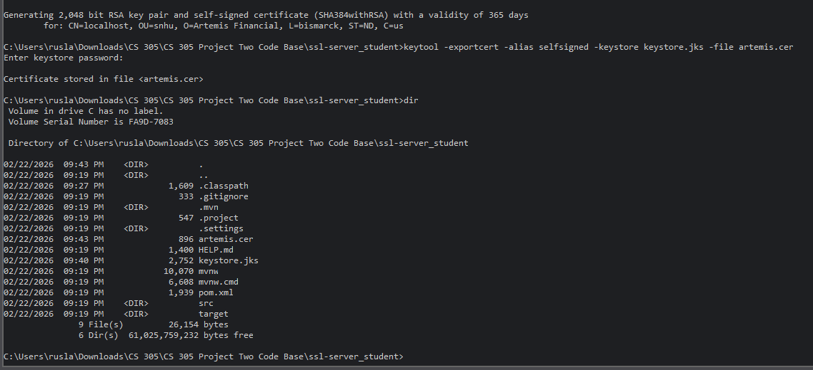
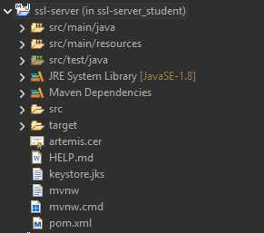

Deploy Cipher
Insert a screenshot below of the checksum verification.

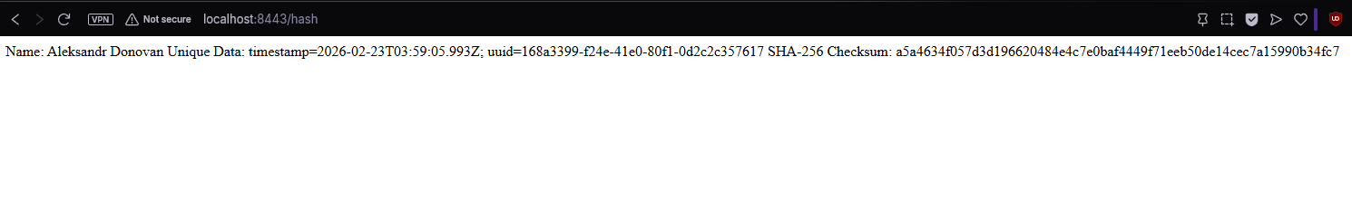

Secure Communications
Insert a screenshot below of the web browser that shows a secure webpage.



Secondary Testing
Insert screenshots below of the refactored code executed without errors and the dependency-check report.
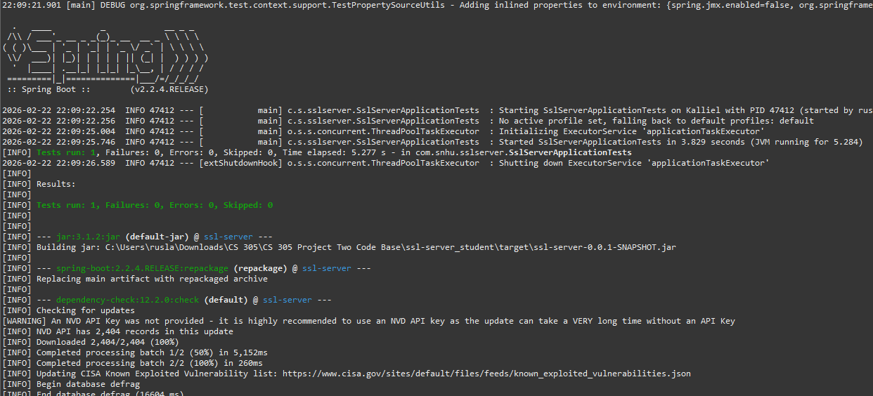

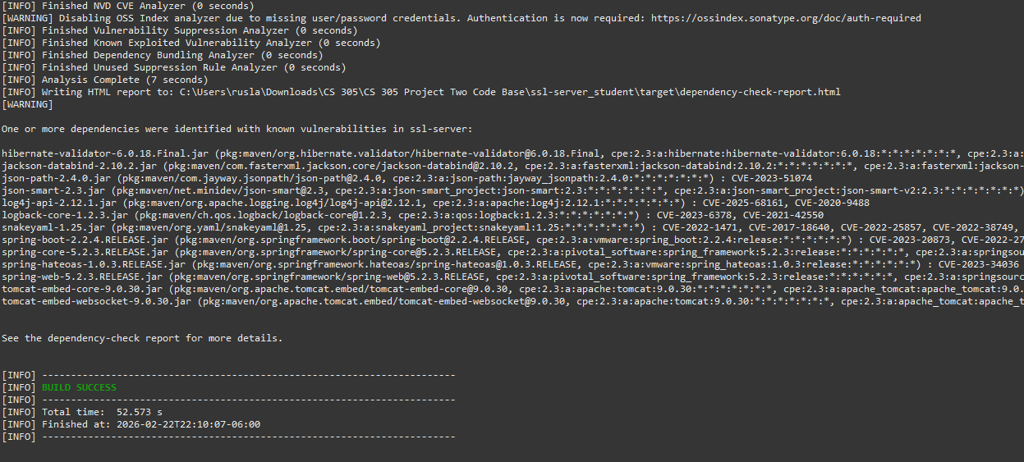

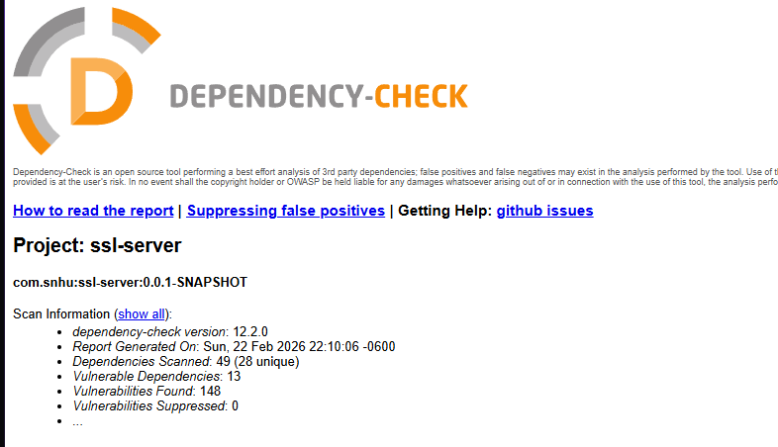
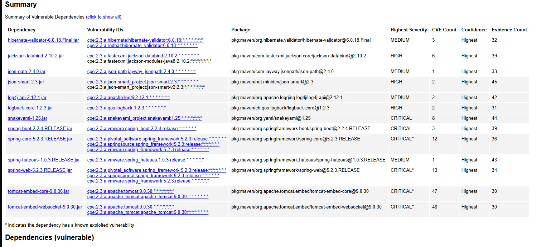

Functional Testing
Insert a screenshot below of the refactored code executed without errors.

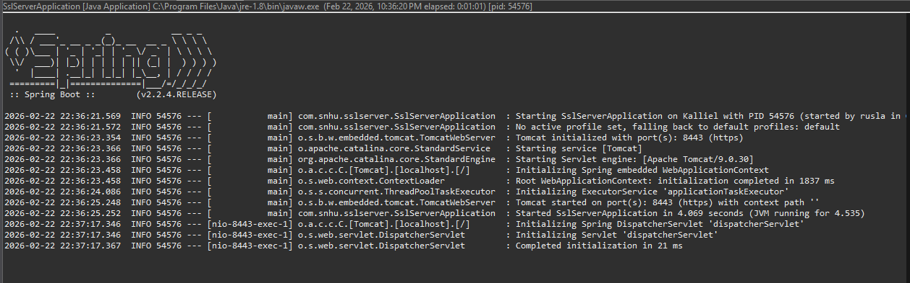
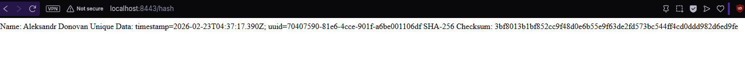

Summary
This project followed a structured vulnerability assessment process to evaluate the security of a Spring Boot–based web application. The assessment began with an architecture review of the application’s client–server design and its reliance on third-party dependencies. This initial review helped identify areas for potential vulnerabilities and guided subsequent testing.
Next, cryptographic practices were examined to ensure the use of modern encryption algorithms and appropriate key sizes. This step reduces the risk of data interception and protects sensitive information during transmission.
To verify that secure communication was properly implemented, HTTPS was configured using a self-signed certificate generated with Java Keytool. As a result, the application was successfully deployed and demonstrated encrypted client–server communication, ensuring that data transmitted between the client and server was protected in transit.
Following the secure communication, secondary testing was performed using OWASP Dependency-Check to analyze third-party libraries for known vulnerabilities. This identified multiple vulnerabilities associated with the framework and dependency versions. These were documented for potential risks and reinforced the importance of ongoing dependency monitoring and updates.
Functional testing was performed through manual code review and execution of the application. This test verified syntactical correctness, logical flow, and secure configuration, while also confirming that the security enhancements did not introduce functional regressions.
Overall, the assessment followed a layered approach combining architectural analysis, secure communication configuration, automated vulnerability scanning, and manual functional testing. This process was to demonstrate how secure software development practices can be integrated throughout the development lifecycle to identify risks early and strengthen application security.

Industry Standard Best Practices
Industry-standard practices were applied throughout this project to mitigate known security vulnerabilities while preserving the application’s functionality. A key practice was the use of modern, approved cryptographic standards to protect the data in transit. HTTPS was configured using a self-signed certificate generated with Java Keytool to ensure encrypted client–server communication. This step reduced the risk of interception or unauthorized access. Using modern cryptographic standards also aligns with accepted security guidance from organizations such as NIST and OWASP, leading cybersecurity frameworks that together provide comprehensive security from high-level governance to technical, application-level implementation.
In addition to secure communication, third-party dependencies were analyzed using OWASP Dependency-Check to identify known vulnerabilities. Rather than modifying application code, this process evaluated potential security risks while maintaining system stability. This step revealed the importance of ongoing dependency monitoring as part of secure software maintenance.
Manual testing and code review were also done to confirm that the application executed without syntactical or logical errors. This step supported secure coding principles such as predictable behavior and fail-safes. This ensured that new security measures did not negatively affect reliability or availability.
Applying these industry-standard secure coding practices provides significant value to the overall well-being of the application. Secure communication helps protect sensitive customer and business data, reducing exposure to data breaches and regulatory violations. Proactive vulnerability identification through dependency analysis further lowers risk by allowing issues to be addressed before possible attacks. These practices, integrated into the development lifecycle, reduce operational risk, strengthen customer trust, and support long-term, secure application growth.

